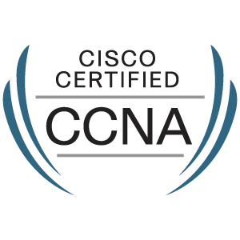
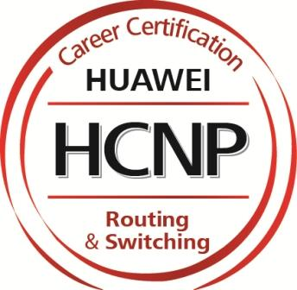

BIRENDRA KUMAR MISHRA
Email-bkm.kse@gmail.com
Mob-8895592151

Career Objective:

Intend to build a career with a leading core firm, which will help me to actualize potential, give me a chance to get a practical implementation of my knowledge and explore myself fully. To be a Team Player, motivating others along the way and to gradually take up role of the Team Leader.

Professional Summary:
- 2 years and 8 month of experience in System Admin and Network Maintenance.
- CISCO Routers, Switches & Firewall (basic configuration)
- Detailed understanding of TCP/IP protocols, RIP, OSPF,BGP protocols.
- Knowledge with built different topology, crimping.
- Knowledge in Monitoring tool like Solar Winds,Ups Monitoring .
- Win 98, 2000,2003,2008,2012 Server, Win XP, Windows Vista, win 7, win 8 Windows NT Excellent skills in troubleshooting at desktop and server related problems.
- Analytical and technical expertise’s in data recovery through 3rd party software.
- Accept the challenge of repairing the devices which were rejected form others.
- Maintain the proper communication through LAN between various departments.
- Creating different type of cross over cable, straight through cable.
- Installing and configuring windows Server 2012 Active Directory Services.
- Managing and Administrating all user domain and accounts.
- Networking, LAN, trouble shooting, Knowledge of configure and maintenance.
- DHCP (Dynamic host configuration protocol) DNS (Domain Name Service), WDS (Windows Deployment Service)
- Assembling and reassembling of computer peripherals.
- Expertise in defect resolution by coordinating with development and business teams
- Strong analytical skills and resolving technical issues
- Mentoring and Knowledge Transfer to team members
- Presentations to clients and senior management
- Ability to work in highly stressed situations.
- Strong communicator and maintain relationship with Colleagues and Clients.
- Good interpersonal skills, commitment, result oriented, hardworking and zeal to learn new technologies and undertake challenging tasks.
- Issuing fixes for technical and extending support for non-technical inquiries and handle escalated events from business customers and tier 1 technical support teams around the globe.

Professional Experience:
- May 5th -2014 to 28th -Dec-2015 as a System Administrator at CENTRAL TOOL ROOM & TRAINING CENTER, Bhubaneswar.
- Feb 11th - 2016 to Till Now as a System Admin in TEAM COMPUTERS PVT LTD.
Educational Qualification:
- B Tech in Computer Science from I.I.E.T Bhubaneswar, year of 2014.
Vocational Training and Courses:

- Completed six month Hardware and Networking course in Central Tool Room & Training Center (CTTC), Bhubaneswar.
- Completed HCNP-R&S(Fast Track) examination Successfully.(CD 1823669)
- Completed four month CCNA course in Central Tool Room & Training Center (CTTC), Bhubaneswar, with CISCO certified.
- DCA and PGDCA at Institute of Information and Web Technology.
- An attended Soft skill class held in College of Engineering Bhubaneswar (C.E.B) and
was a part of Infosys Campus Connect Program.

Technical Skills:
- Operating Systems: Windows XP, Windows Vista, Windows7, 8,& 10 Linux.
- Hardware testing Tools: Multi meter, Cable tester, Card tester, Soldering de-soldering.
- Application software: Password cracker, Winrar, DVD Convertor, Nero.
- Office Package: Microsoft Word, Microsoft Excel, Microsoft PowerPoint, Microsoft Outlook Express.
- Maintenance: Troubleshooting, loading of different operating system

Achievements:
- Awarded Best Captain prize in Inter College Cricket Tournament organized at
- Koustuv School of Engineering, Bhubaneswar.
- Awarded various prizes for participating in Song Competition organized by
- Koustuv School of Engineering, Bhubaneswar.
- Awarded certificate of appreciation for voluntary donating blood in the camp organized by RED CROSS SOCIETY, ODISHA.

Personal Details:
Name : Birendra Kumar Mishra
Sex : Male
Marital Status : Single
Nationality : Indian
Language Known : English, Hindi, Oriya
Hobby : Singing, Dancing , Learn new things form others.

Declaration:
I hereby declare that the information furnished above is true to the best of my knowledge.

Place: Bangalore
Date: Birendra Kumar Mishra

